Vincent Ryan

6/30/2024

Module 6.2 - MySQL First Exposure

Here is the result from running the requested script in VS Code. I could not get the “source <code>” to run correctly within the shell. Firstly I learned that in windows slashes need to be forward, not backward slashes otherwise SQL reads them as commands. However even after this it couldn’t run correctly. I find it unlikely it was typed incorrectly since I copied the pathway directly from the file but I suppose that’s the last option. Either way I got this to correctly run using VS Code.

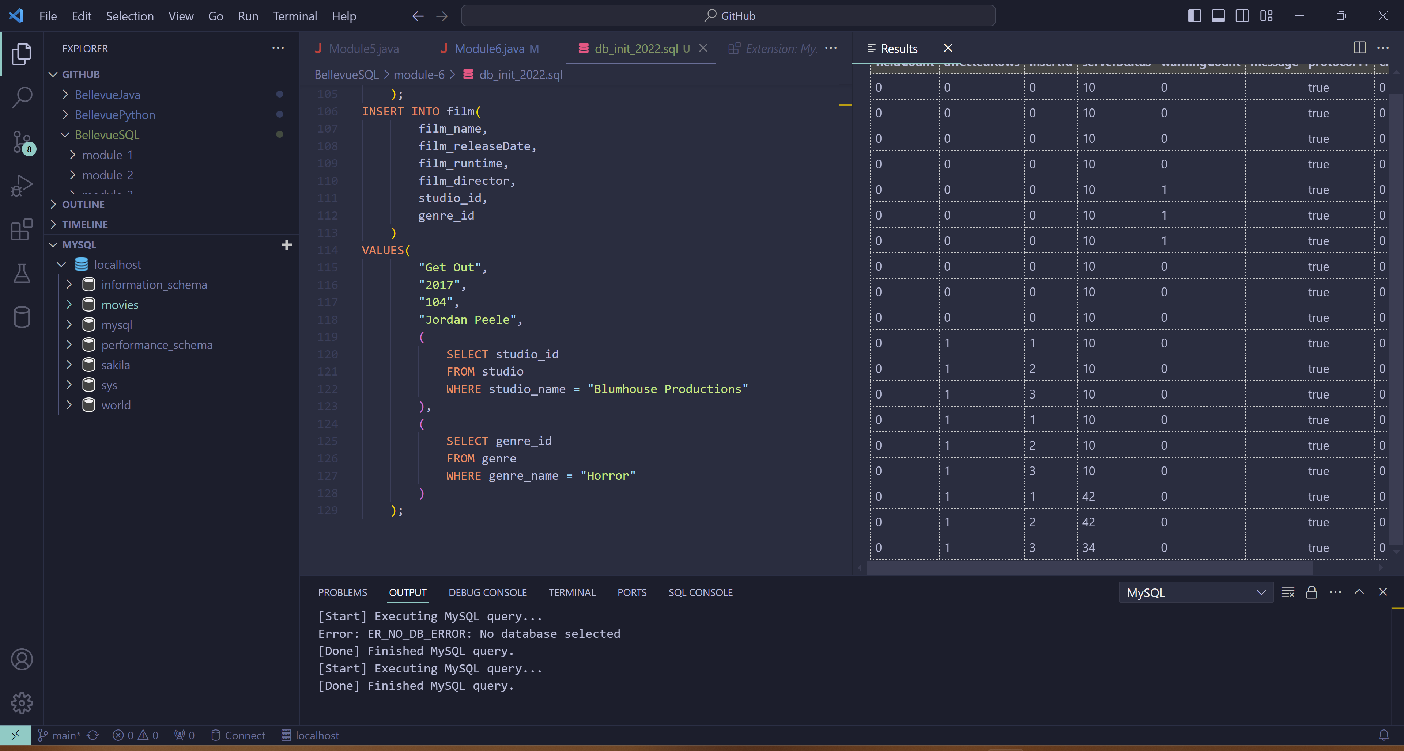

Here is the result of this action using SHOW TABLES inside of the SQL Shell.

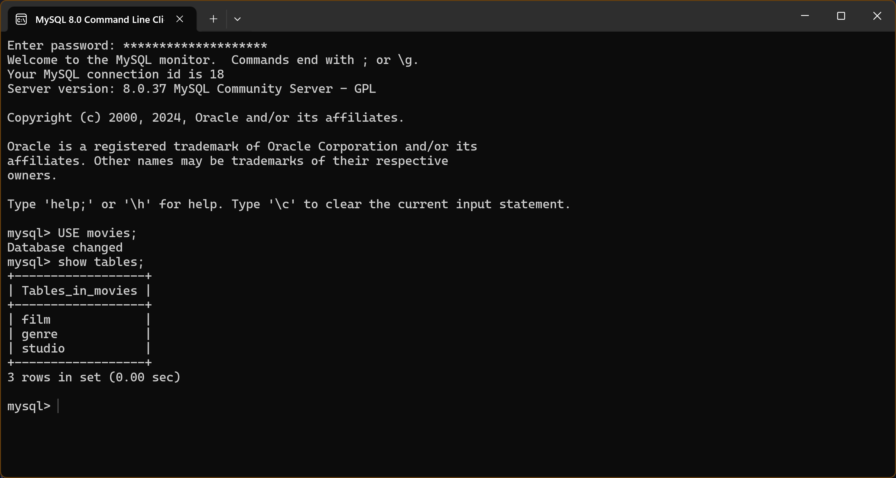

Here is the result of running the Python code. As expected by following through the code, nothing occurred since there were no errors.

